Project Draft

Towards Better Data Imputation with Machine Learning



|  |  |
| --- | --- |
| Name: | Supervisor: |
| Student ID: |  |
| Word Count: 2729 (Without References) |  |
| Date: |  |

Table of Contents

Table of Figures 2

Abstract 3

Introduction 3

Background 4

Aim/Objective 4

Research Questions 4

Ethical Considerations 4

Literature Review 4

Project Timeline 8

Experimentation 8

Project Evaluation 9

Conclusion 9

References 9

# Table of Figures

Figure 1 - Literature Review Workflow 5

Figure 2 - Randomized Data Imputation Results from Listwise Deletion, PMM and Poisson Imputation 7

Figure 3 - Results of the Wine Dataset 8

Figure 4 - Results on the Glass Dataset 8

Figure 5 - Results of the Concrete Compressive Strength Dataset 8

Figure 6 - Results of the Liver Patient Dataset 8

Figure 7 - Results on the Seeds Dataset 9

Figure 8 - Project Timeline 9

Figure 9 - Dataset Visualization 10

# Abstract

Artificial Intelligence (AI) as a strategy for carrying out AI implanted thoughts has acquired a huge foothold since the previous twenty years. This has prompted a remarkable expansion in the improvement of Machine Learning and the number of scientists that attention to improving ML. The quick advancement of Machine Learning wouldn't have been conceivable if there wasn't sufficient information to go on.

All Machine Learning (ML) projects are vigorously needy and there is no ML without information. The significance and meaning of information are unreplaceable to ML. In that capacity, the information accessible for ML projects should be ideal for exact outcomes. Yet, regularly this isn't the situation. The cycle of dataset assortment is currently getting mechanized through web scrappers and other comparable devices. These outcomes in datasets aren't as awesome and exact. They may be feeling the loss of certain qualities or the qualities probably won't be of the appropriate configuration.

This exploration means utilizing the ability of Machine Learning, particularly relapse to counter this issue of missing qualities in datasets. The yield of this exploration would be the test examination of applying ML to datasets to counter their missing qualities.

**Keywords:** Machine Learning, Artificial Intelligence, Missing Qualities

# Introduction

Dynamic dependence on data from information is exceptionally subject to the honesty of the information (Bengtsson and Lindblad, 2020). For investigation of information being pretty much as exact as could be expected, it follows that the information should be just about as precise as could be expected (Bengtsson and Lindblad, 2020). Precise information suggests that the information is finished since fragmented information increment the danger of debilitating the legitimacy (Bengtsson and Lindblad, 2020). In any case, in reality, information will in general be inadequate (Bengtsson and Lindblad, 2020). By and large, the deficiency is because of the difficult issue of missing qualities (Bengtsson and Lindblad, 2020). A missing worth happens when perception doesn't have a gathered incentive for a variable (Bengtsson and Lindblad, 2020). With missing qualities, data about the populace is missing which dangers having information that doesn't mirror the populace honestly. This can affect the ends drawn from the information (Bengtsson and Lindblad, 2020).

By and large quantifiable and AI computation isn't adequately amazing to manage missing characteristics (Jadhav, Pramod and Ramanathan, 2019). They get affected by missing data. Missing data presents a part of vulnerability while taking apart data and that can impact properties of quantifiable assessors and results in loss of power and misdirecting closes (Jadhav, Pramod and Ramanathan, 2019). Fittingly overseeing missing characteristics is a huge and testing task since it requires: (Jadhav, Pramod and Ramanathan, 2019)

1. Appraisal of all instances of data to recognize illustration of missingness in the data and
2. A clear understanding of different credit techniques.

This exploration venture will bring about an algorithmic methodology that will want to handle this issue in regards to missing information occasions.

## Background

Information is the thing that reigns the 21st century. The approach of innovation and the dramatic ascent in the accessibility of innovation to the majority has caused a quick flood in information utilization and creation. Taking care of a particularly gigantic information stream at each second gets burdening and here and there botches are made while information recording. These mix-ups cause holes that cause blemishes in the measurements that are performed on the information and impact the total after interaction and results.

This issue perseveres since the strategies for managing this aren't grown however the information utilization and creation are soaring each second. This is the thing that started the exploration for a procedure that can handle this.

## Aim/Objective

The point here is make an AI that gives recuperation or substitution to any absent or conflicting information in an individual dataset. The dataset utilized will be of the clinical area. The accompanying advances when followed will help accomplish this point:

* Writing survey of the work done by specialists in similar area to learn of the mainstream calculations utilized for information attribution.
* Dataset determination and information pre-preparing. In any case, during the time spent pre-handling, the missing qualities won't be prepared since that will be finished by the calculation.
* Planning the Machine Learning Algorithm. The dataset measurements will be noticed and the appropriate calculation will be utilized to decide the missing qualities in the information. The worldview for this Machine Learning Research Project will be Regression. Along these lines, Regression calculations like SVM Regressor, MLP Regressor, ARIMA and Multivariate Linear Regression calculations will be utilized for this reason. These calculations will be accessible from the scikit-learn library for Python.
* Execution Metrics for the Algorithms. Since exactness can't be determined for Regression calculations, their presentation must be estimated as a blunder in its forecasts. To quantify these blunders, the accompanying ways are utilized:

|  |  |
| --- | --- |
| Performance Metric | Formula |
| Mean Squared Error (MSE) | If **n** predictions are produced from a dataset with **n** data instances; where **Y** is the vector of labels in the dataset and $\hat{Y}$ is the vector of predicted labels, then $MSE= \frac{1}{n}\sum_{i = 1}^{n}{{(Y_{i }- \hat{Y_{i}})}^{2}}$ |
| Root Mean Squared Error (RMSE) | $$RMSE= \sqrt{MSE}$$ |
| Mean Absolute Error (MAE) | $$MAE= \frac{1}{n}\sum_{i}^{n}{(Y_{i}{ - \hat{Y}}_{i})}$$ |

## Research Questions

The following questions provide the direction to this project:

1. Can AI give the help required in battling the issue of missing information occasions?

## Ethical Considerations

The UK Data Service division also offers rules to moral investigation with express association with Big Data. These standards will outline the justification of this current report's ethical philosophy. The focuses that should be centred around are:

* Keeping information confidential that ignores pack insurance,
* Alluding to focal points for all information used inside the assessment project,
* Ensuring all data is taken care of in the correct territory.

## Literature Review

The measure of missing values gives some insight into how much the missing qualities influence the outcomes, as it is identified with its effect on research ends (Bengtsson and Lindblad, 2020). For the most part, bigger extents of missing qualities will in general greatly affect factual surmising and generalizability since it shows that more data about the populace is missing (Bengtsson and Lindblad, 2020). The example information may mirror an inclination as a great deal of noticed information gets erased because of a ton of perceptions acquiring missing qualities, prompting one-sided boundary appraises and misdirecting measurable derivation (Bengtsson and Lindblad, 2020).

This makes Literature Review, the way toward alluding to the examination done by peers in a similar area obligatory. Since there is a lot of work done in this field, a method to proceed with this is made as shown in *Figure 1*.

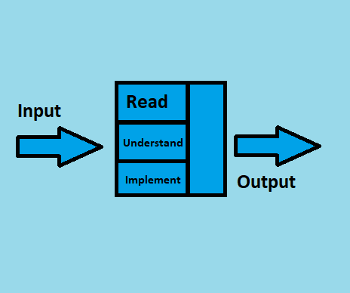

Figure - Literature Review Workflow

As insinuated above, work is being done on this point for a long time back. In this time, a huge load of the review material, expressly assessment papers have amassed for anyone that necessities to do a Literature Review. In any case, examining the total of the papers now isn't possible. Thusly, a course of action for picking quality papers needs to in place. The technique is according to the going with:

* English ought to be the lone language in the papers.
* Should be spread in diaries with a high effect factor.
* Complete and free access should be accessible for the Paper and the Journal.
* All the evaluation datasets and code for the papers should be open.
* 10 years old assessment isn't allowed.

The papers chosen to concentrate on in this examination are talked about in this segment. The technique/tests led in these examination papers and the outcomes that those trials bore will be the primary focal point of this segment.

Missing data is the most notable issue experienced by AI subject matter experts while analyzing genuine data. In various applications going from quality verbalization in computational science to examine responses in humanistic systems, missing data is accessible to various degrees (Bertsimas, Pawlowski and Daisy Zhuo, 2018). As various quantifiable models and AI estimations rely upon complete enlightening records, it is crucial to managing the missing data appropriately. Here and there, fundamental philosophies may get the job done to manage missing data. For example, a total case assessment uses simply the data that is known and blocks all insights with missing characteristics to prompt verifiable assessment (Bertsimas, Pawlowski and Daisy Zhuo, 2018).

These capacities commendably two or three discernments contain missing characteristics, and when the data is missing absolutely at sporadic, complete case assessment doesn't expeditious uneven outcomes (Bertsimas, Pawlowski and Daisy Zhuo, 2018). On the other hand, a couple of AI estimations ordinarily address missing data, and there is no necessity for pre-taking care of it. For instance, CART and K-infers have been adapted to issues with missing data. In various conditions, missing characteristics ought to be ascribed to going before running quantifiable assessments on the absolute educational file (Bertsimas, Pawlowski and Daisy Zhuo, 2018).

Analysts have been chipping away at this issue for some time before and have concocted creative, new and novel ways to deal with taking care of Data Imputation. The Literature Review for this exploration centres on ways to deal with Data Imputation after 2014. The methodologies for Data Imputation are for the most part measurable, yet as of late more inventive and novel methodologies are showing up in the Literature i.e., profound learning, generative antagonistic learning, fluffy rationale, Autoencoders and some more.

Missing data is ubiquitous in gigantic data clinical starter. Through various assessments don't unequivocally report how they handle missing data, some evident procedures are used in quantifiable programming. In this manner, different packs may surprisingly manage missing data (or the default systems are extraordinary) and results may not be duplicated decisively by using assorted quantifiable programming groups (Zhang, 2016). Sometimes, this may not prompt on a very basic level different results, yet the consistent sufficiency of the examination is sabotaged. The best practice is to explicitly state how missing characteristics are dealt with. For ease, various experts eradicate insufficient case (Listwise exclusion), which is similarly the default procedure in various backslide packs (Zhang, 2016).

This methodology gets trustworthy results exactly when the amount of missing characteristics isn't huge and the missing model is missing unpredictably (MCAR) or missing MAR. Another insult to complete case assessment is information adversity. This can be a significant issue when there is a gigantic number of components (sections) (Zhang, 2016). A liberal number of cases can be deleted because abrogation relies upon missing values on at any rate one elements. Additionally, a total case examination can incite unpredictable tendency (Zhang, 2016). The response to this issue is attribution. Missing characteristics are displaced by attributed values. Since credit is a space of dynamic assessment, there are different strategies and groups made for attribution (Zhang, 2016).

The missing qualities are generally assessed utilizing focal inclination estimates like mean, middle and mode in numerous sorts of exploration (Zhang, 2016). The mean and standard deviation are uneven. Attributions with mode and centre work along these lines and they are left to clients for preparing (Zhang, 2016). But unforgiving attribution gives speedy and fundamental procedures to missing characteristics, it puts down change, deals with the association among variables, and tendencies summary experiences. Thus cruel attributions should be used when an unobtrusive pack of characteristics are missing, they are not for general use (Zhang, 2016).

A few specialists use Listwise Deletion, Predictive Mean Matching and Poisson Imputation for handling the information ascription issue (Bengtsson and Lindblad, 2021). The outcomes for these strategies from the paper by (Bengtsson and Lindblad, 2021) are as per the following:

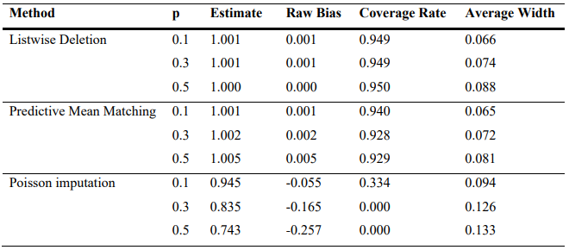

Figure - Randomized Data Imputation Results from Listwise Deletion, PMM and Poisson Imputation

Attributions utilizing Central Tendency measures are mainstream among specialists in this area. Different methodologies like the Predictive Mean coordinating with Discussed above is additionally famous among scientists. Respectably utilized methodologies for Data Imputation additionally incorporate Imputing utilizing bunching strategies like k-NN, attributing utilizing probabilistic techniques like the Bayes hypothesis and conventional relapse calculations like the Linear relapse. Aftereffects of these calculations from the exploration done by (Jadhav, Pramod and Ramanathan, 2019) are as per the following:

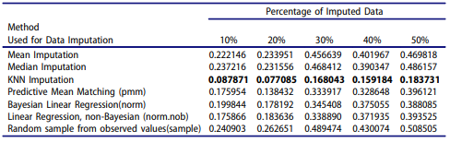

Figure - Results of the Wine Dataset

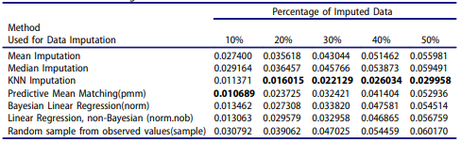

Figure - Results on the Glass Dataset

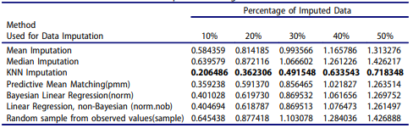

Figure - Results of the Concrete Compressive Strength Dataset

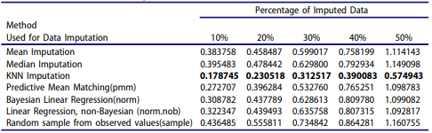

Figure - Results of the Liver Patient Dataset

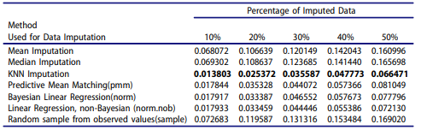

Figure - Results on the Seeds Dataset

The outcomes from these investigations demonstrate the legitimacy and the strength of these methodologies. It demonstrates why these methodologies are so mainstream and more than once utilized in this space. Albeit the methodology isn't the solitary factor influencing the outcomes. The execution of the methodology on chose datasets likewise matters a ton. That is the reason (Jadhav, Pramod and Ramanathan, 2019) utilized five datasets to demonstrate the strength of the exhibition of different well known Data Imputation strategies.

## Project Timeline

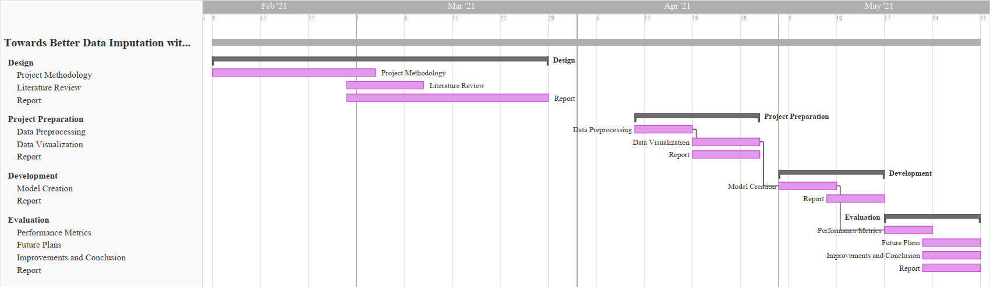

Figure - Project Timeline

# Experimentation

The dataset utilized will be the RAPID (Real-time Adaptive and Predictive Indicator of Deterioration) project that gathers and examinations ongoing patient information and alarms if the patient wellbeing is declining. The worldview from the examination of the dataset and the audit of the Research Questions has been derived to be Regression. The highlights in the dataset are as per the following:

* **Timestamp**: The time at which the information occasion was recorded.
* **Lifetouch Heart Rate**: The pulse of the Patient record.
* **Lifetouch Respiration Rate**: The breath pace of the Patient record.
* **Oximeter SpO2**: Blood oxygen levels on the Patient record.
* **Oximeter Pulse**: Patient heartbeat recorded.

This information has been recorded continuously from the patients. On perception, the dataset has issues like missing qualities, values that don't follow the example for example - 1. These issues must be checked to build the nature of the dataset and the aftereffects of the Machine Learning calculation. Subsequently, information pre-handling is compulsory for this venture.

The quantity of highlights isn't so many. Additionally, from noticing the dataset, the worldview of this AI undertaking can be chosen as relapse. The dataset is time-arrangement information giving finding on the patient. This information will be utilized to foresee the impending qualities for these highlights ahead of time. This will help anticipate if the patient's wellbeing will decay or not. Relapse calculations will be executed for this examination project. AI libraries for Python like scikit-learn give numerous Regression calculations like ANN Regressor, SVM Regressor, ARIMA and some more. These calculations will be utilized to prepare and foresee this dataset.

Figure - Dataset Visualization

The dataset is not a large dataset with just four highlights to work with. The pattern line diagram above is of the dataset. It shows how the four highlights in the dataset circle back to time. Each element is special and essential to the dataset. The justification this is that there are as of now less highlights to work with. The lone conceivable information cleaning for this dataset will be to fill the missing qualities. That will be finished by the finalized ML ensemble made in this examination.

# Project Evaluation

The assessment will be done using the going with information:

* The yield of the associate appraisals following with assessing the computation execution.
* The quantifiable evaluation of the dataset.

# Conclusion

The significance of Data ascription increments with the increment in information. The expansion in information has been dramatic. It is not, at this point a human accomplishment to gather and oversee information. Information assortment is being computerized. Thusly, the subsequent datasets may contain blames or may have an instance of missing qualities. This examination centres on taking care of this issue utilizing the relapse worldview in Machine Learning RAPID (Real-Time Adaptive and Predictive Indicator of Deterioration).

# References

1. Bengtsson, F. and Lindblad, K., 2021. Methods for handling missing values: A simulation study comparing imputation methods for missing values on a Poisson distributed explanatory variable. Uppsala University, [online] Available at: <https://www.diva-portal.org/smash/get/diva2:1520218/FULLTEXT01.pdf> [Accessed 5 February 2021].
2. Jadhav, A., Pramod, D. and Ramanathan, K., 2019. Comparison of Performance of Data Imputation Methods for Numeric Dataset. Applied Artificial Intelligence, 33(10), pp.913-933.
3. Jason Anastasopoulos, L. and G.Hunter, S., 2020. Fast and Robust Missing Data Imputation. researchgate.net, [online] Available at: <https://www.researchgate.net/publication/347741781_Fast_and_Robust_Missing_Data_Imputation> [Accessed 5 February 2021].
4. Jin, L., Bi, Y., Hu, C., Qu, J., Shen, S., Wang, X. and Tian, Y., 2021. A comparative study of evaluating missing value imputation methods in label-free proteomics. Scientific Reports, 11(1).
5. Zhang, Z., 2016. Missing data imputation: focusing on single imputation. Annals of Translational Medicine, [online] 4(1). Available at: <https://www.ncbi.nlm.nih.gov/pmc/articles/PMC4716933/> [Accessed 5 February 2021].
6. Amiri, M. and Jensen, R., 2016. Missing data imputation using fuzzy-rough methods. Neurocomputing, 205, pp.152-164.
7. BEAULIEU-JONES, B. and MOORE, J., 2016. MISSING DATA IMPUTATION IN THE ELECTRONIC HEALTH RECORD USING DEEPLY LEARNED AUTOENCODERS. Biocomputing 2017.
8. Bertsimas, D., Pawlowski, C. and Daisy Zhuo, Y., 2018. From Predictive Methods to Missing Data Imputation: An Optimization Approach. Journal of Machine Learning Research, pp.1-39.
9. Duan, Y., Lv, Y., Liu, Y. and Wang, F., 2016. An efficient realization of deep learning for traffic data imputation. Transportation Research Part C: Emerging Technologies, 72, pp.168-181.
10. García-Laencina, P., Abreu, P., Abreu, M. and Afonoso, N., 2015. Missing data imputation on the 5-year survival prediction of breast cancer patients with unknown discrete values. Computers in Biology and Medicine, 59, pp.125-133.
11. Li, Z., Sharaf, M., Sitbon, L., Sadiq, S., Indulska, M. and Zhou, X., 2013. A web-based approach to data imputation. World Wide Web, 17(5), pp.873-897.
12. Yoon, J., Jordon, J. and van der Schaar, M., 2018. GAIN: Missing Data Imputation using Generative Adversarial Nets. Proceedings of the 35th International Conference on Machine Learning.